EXPERIMENT 1:

Experiment based on network theorems (KCL, KVL)

**Aim:**

1) To verify KVL and KCL.

2) To study the effect of some modifications in special circuits.

**Apparatus Required:**

DC voltage supply(5V), breadboard, connecting wires, resistors of various values as shown in the circuit diagrams, multi-meter, etc.

***Theory:***

Kirchhoff’s Law: A German physicist Gustav Kirchhoff developed two laws enabling easy analysis of an interconnection of any number of circuit elements. The first law deals with the flow of current and is popularly known as Kirchhoff’s Current Law (KCL) while the second one deals with the voltage drop in a closed network and is known as Kirchhoff’s Voltage Law (KVL).

The KCL states that the summation of current at a junction remains zero and according to KVL the sum of the electromotive force and the voltage drops in a closed circuit remains zero. While applying the KCL the incoming current is taken as positive and the outgoing current is taken as negative. Similarly, while applying KVL, the rise in potential is taken as positive and the fall in potential is taken as negative.

***Part 1***

***Circuit Diagram***

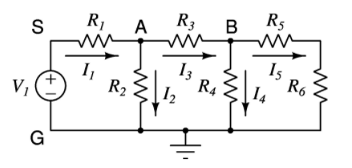

Fig. 1

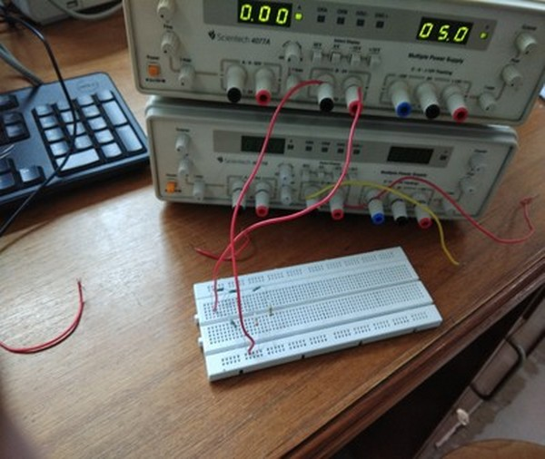***Snapshot of breadboard***

* Connect the network below. V1 is 5 volts; R1 is 100Ω; R2 is 220Ω; R3 is 100Ω; R4 is 220Ω; R5 is 47Ω and R6 is 150Ω.
* Measure each resistance by opening them out of the circuit and using a multi-meter.
* Measure voltages across all resistances in the circuit using a multi-meter. Calculate the currents expected to flow through these resistors.
* Verify KCL for node-A and node-B.
* Verify KVL for all possible loops.
* Connect a 470Ω resistor between S and G; measure the change in the current I5. Now connect the same 470Ω resistor across R6 and measure the change in the current I5.

***Observation***

|  |  |  |  |
| --- | --- | --- | --- |
| Resistors | Resistance (Ω) | Voltage (V) | Current (mA) |
| R1 | 99.6 | 2.418 | 24.277 |
| R2 | 216.1 | 2.538 | 11.744 |
| R3 | 98.7 | 1.245 | 12.614 |
| R4 | 216.5 | 1.29 | 5.958 |
| R5 | 46.2 | 0.307 | 6.645 |
| R6 | 147.8 | 0.983 | 6.651 |

On connecting 470Ω resistor across SG,

V5` = 0.306 V and I5` = 6.623 mA

Change in current (| I5` - I5 |) = 0.022 mA

On connecting the same resistor parallel to R6,

V5`` = 0.350 V and I5`` = 7.576 mA

Change in current (| I5`` - I5 |) = 0.922 mA

Verification of KCL for node A

Iin = I1 = 24.277 mA

Iout = I2 + I3 = 11.744 mA + 12.614 mA = 24.538 mA

Iin is approximately equal to Iout.

Hence verified.

Verification of KCL for node B

Iin = I3 = 12.614 mA

Iout = I4 + I5 = 5.958 mA + 6.645 mA = 12.603 mA

Iin is approximately equal to Iout.

Hence verified.

Verification of KVL for Loop 1

V1 – VR1 – VR2 = 5V – 2.418V – 2.538V = 0.044V

This is within the limits of experimental error.

Hence verified.

Verification of KVL for Loop 2

VR2 – VR3 – VR4 = 2.538V – 1.245V – 1.29V = 0.003V

This is within the limits of experimental error.

Hence verified.

Verification of KVL for Loop 3

VR4 – VR5 – VR6 = 1.29V – 0.307V – 0.983V = 0

Hence verified.

Verification of KVL for Loop 4

V1 – VR1 – VR3 – VR4 = 5V – 2.418V – 1.245V – 1.29V = 0.047V

This is within the limits of experimental error.

Hence verified.

Verification of KVL for Loop 5

VR2 – VR3 – VR5 – VR6 = 2.538V – 1.245V – 0.307V – 0.983V = 0.003V

This is within the limits of experimental error.

Hence verified.

Verification of KVL for Loop 6

V1–VR1 – VR3 – VR5 – VR6 = 5V – 2.418V – 1.245V – 0.307V – 0.983V = 0.047V

This is within the limits of experimental error.

Hence verified.

***Result***

KCL and KVL is verified.

***Part II*** (Circuit of Fig.1)

* Move one end of R5 out and connect a 5 volt source in series with R5. The positive side of the voltage source should be towards B. Measure the voltage across R2 and calculate the current I2.
* Recall that you had calculated I2 earlier when there was only V1 of 5 volts.
* Now replace V1 with a short circuit. Again measure the voltage across R2 and calculate I2.
* Verify the superposition theorem.

***Observation***

Without short-circuit,

V2` = 3.197V and I2` = 14.794 mA

With short-circuit,

V2`` = 0.675V and I2`` = 3.123 mA

According to superposition theorem,

I2 + I2`` = I2`

LHS = 11.744 mA + 3.123 mA = 14.867 mA

RHS = 14.794 mA

***Result***

The LHS and RHS are within experimental error limits. Hence superposition theorem is verified.

***Part III***

* Setup a circuit as shown below. Each resistor is 120Ω.
* Measure the resistance between nodes A and B. Use a multi-meter for this purpose. What is the expected resistance between nodes A and B? Does the expected value agree with the measured value?
* Apply a voltage of 5 volts between A and B. Measure voltages between B-C, B-D, C-D. Make comments about the observed voltages.
* Replace C-D with a short-circuit. Measure the voltages across the resistances; measure the resistances; and calculate the current in A-A'. Comment on your observations.
* Replace C-D with an open-circuit. Once again measure the voltages across the resistances and calculate the current in A-A'. Comment on your observations.

***Circuit Diagram***

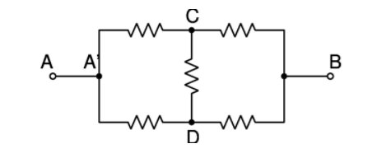

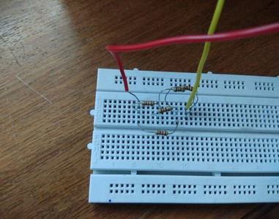***Snapshot of Breadboard***

***Observation***

|  |  |  |  |  |
| --- | --- | --- | --- | --- |
| Branch | Resistance (Ω) | Voltage (V) | Voltage after shorting CD (V) | Voltage after removing CD (V) |
| AC | 118.7 | (not required) | 2.501 | 2.498 |
| CB | 118.8 | 2.503 | 2.500 | 2.501 |
| CD | 118.4 | 0.001 | (not applicable) | (not applicable) |
| AD | 118.8 | (not required) | 2.499 | 2.502 |
| DB | 118.8 | 2.502 | 2.502 | 2.501 |

Resistance of the entire combination (RAB) = 118.8Ω (measured by multimeter)

Resistance of the entire combination (RAB) = 118.8 Ω (theoretical)

After short-circuiting CD, IAA` = IAC + IAD = + = + = 21.070mA+21.035mA = 42.105 mA

After removing CD, IAA`` = IAC` + IAD` = + = + = 21.045mA+21.061mA = 42.106 mA

***Result***

* The theoretical and experimental value for RAB is same.
* The voltages across CB and DB is practically same while across CD is practically 0.
* The current IAA` remains practically the same with/without(open/short) CD.
* All this verifies the balanced wheatstone bridge condition.

***Part IV (mystery)***

***Procedure***

* Consider the circuit of Part-1. You have already measured all the voltages (and inferred all the currents) in all the branches of the circuit. Let us call this set of voltages and currents as {ViA} and {IiA}.
* Now do a fresh measurement for a similar circuit, with different values of voltages and components. The voltage source can be any value of your choice. The resistors R1 through R6 can be arbitrarily chosen from 47Ω, 100Ω, 150Ω and 220Ω. Make sure that the circuit components are not the same as the previous circuit; any other choice is okay. Measure all the voltages, and infer all the currents; let us call this set of voltages and currents as {ViB} and {IiB}.
* Compute ∑i(ViAIiB). That is from the set A, choose the ith voltage and from set B choose the ith current. Multiply them and add. You can also compute ∑i(ViBIiA). Comment on the surprising result.

***Snapshot of Breadboard***

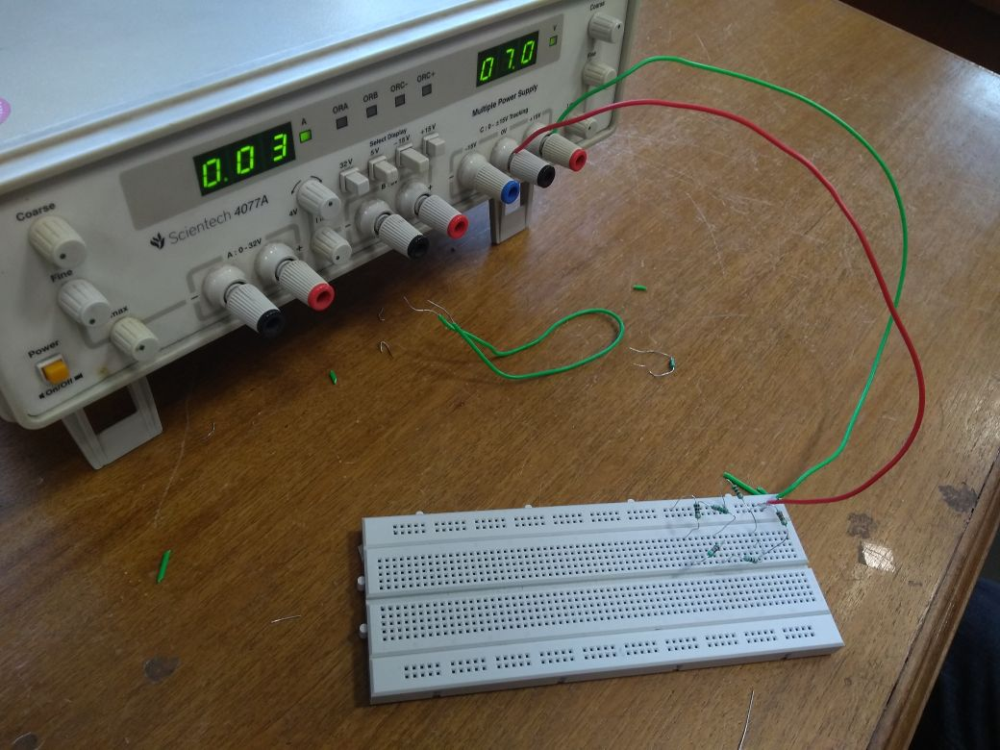

***Observation***

Vapplied = 7.0 V

|  |  |  |  |  |  |  |  |
| --- | --- | --- | --- | --- | --- | --- | --- |
| Resistors | R (Ω) | VB (V) | IB (mA) | VA­ (V) | IA (mA) | VBIA (V.A) | VAIB (V.A) |
| R1 | 217.6 | 5.554 | 25.524 | 2.418 | 24.277 | 0.135 | 0.062 |
| R2 | 100.0 | 1.525 | 15.250 | 2.538 | 11.745 | 0.018 | 0.039 |
| R3 | 46.7 | 0.483 | 10.343 | 1.245 | 12.614 | 0.006 | 0.013 |
| R4 | 147.1 | 1.041 | 7.077 | 1.29 | 5.958 | 0.006 | 0.009 |
| R5 | 214.8 | 0.713 | 3.319 | 0.307 | 6.645 | 0.005 | 0.001 |
| R6 | 98.9 | 0.326 | 3.296 | 0.983 | 6.651 | 0.002 | 0.003 |
|  |  |  |  |  | ∑ | 0.172 | 0.127 |

***Result***

The difference between ∑(ViAIiB) and ∑(ViBIiA) is 0.045 V.A which is 26% which is within the limits of experimental error.

(Both values should be same ideally)

***Concluding Remarks***

In this experiment we verify the concepts and laws of electrical circuits which we are already familiarized with. Kirchhoff’s current law and voltage law (KVL and KCL) is verified and we also verify the changes that are made by changing or adding some electrical components.

Then we verified superposition theorem and we also encountered a balanced circuit (Wheatstone bridge circuit) and noticed the well-known results of a balanced circuit. Thus this experiment was intended to make us verify the theoretical concepts which we have read earlier. Overall this experiment helped me to view the practical aspects of electrical circuit.